RETURN FORM AND PAYMENT TO:
Tracie Kuehl
Director
820 E Main St.
PO Box 575
Eagle WI 53119
eaglerecreation@townofeaglewi.us
262-949-4232

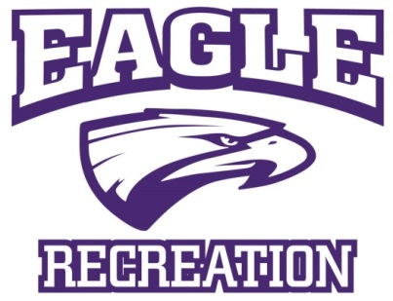

Sponsor Advertising Form

Advertiser Name:
Contact Phone:
Contact Email:
Advertiser Address:
City, State, Zip
Will you use an ad from previous Activity Guides?
Ad Size:

Circle all that apply - type and level of sponsorship
DISPLAY AD RATES - FULL COLOR ADS
AD SIZE | DIMENSIONS (APPROXIMATE) | AD RATES – 3 Program Guides
Business Card - HORIZONTAL | 1.875”x2.5” | $200.00
1/4 page-VERTICAL | 3.75”x5” | $378.00
1/2 page- HORIZONTAL | 5.5”x7.5” | $670.00
1/2 page- HORIZONTAL | 5.5”x7.5” | $950.00
Full page - VERTICAL | 7.5" X 10" | $1,200.00
Ad Corrections/Changes | One time | $15.00 per half hour
Design Fee | Per Ad/Time | $30.00 per hour

Banner Sponsorship – Full Color
AD SIZE | DIMENSIONS (APPROXIMATE) | AD RATES
One sided Banner – Spring Soccer | 4’ x 2’ | $175.00
Two sided Banner – Spring Soccer | 4’ x 2’ | $350.00
One sided Summer Baseball | 4’ x 2’ | $175.00
Two sided Summer Baseball | 4’ x 2’ | $350.00
One sided Fall Soccer | 4’ x 2’" | $175.00
Two sided Fall Soccer | 4’ x 2’ | $350.00
All Sports Sponsor | 4’ x 2’ | $900.00

Jersey Sponsorship
AD SIZE | DIMENSIONS (APPROXIMATE) | AD RATES
Spring Soccer 1 color Sleeve | 2” x 2” | $13.50/shirt
Spring Soccer 2 color sleeve | 2” x 2” | $15.00/shirt
Summer Baseball 1 color sleeve | 2” x 2” | $13.50/shirt
Summer Baseball 2 color sleeve | 2” x 2” | $15.00/shirt
Fall Soccer 1 color sleeve | 2” x 2” | $13.50/shirt
Fall Soccer 2 color sleeve | 2” x 2” | $15.00/shirt
All Sports Sponsor 2 color | 2” x 2” | $13.00/shirt

Jersey sponsorships are on a first come first serve basis. We have two sleeves per jersey with one ad per sleeve. The number of shirts varies by enrollment. You may sponsor one team or a full sport. Banners will be displayed at the Park where the sport is being held for the duration of the activity. In the case where the sport is being held at both locations, the banner will be displayed at the park with the majority of games. If you would like to have a banner at both parks, the amount is 2 times the sport ad rate. You may choose one or more different ways to sponsor, please circle all that apply. If you have any questions or suggestions for a creative way to sponsor the Eagle Recreation activities, please contact Tracie Kuehl, Director of Eagle Recreation at 262-949-4232.

-----------------------------------------------------------------------------------------------------------------------------

PLEASE SUBMIT ADS IN A JPG FORMAT

Full payment must be received to ensure placement in each guide. Banner and shirt sponsorships must be received 4 weeks prior to the beginning of the sport and will be invoiced once the sport registration has been filled. All invoiced sponsorships are due within 30 days of issue.

Checks Payable to: Eagle Recreation
Credit Card Payments accepted at: https://www.govpaynow.com/gps/user/plc/a001ex

Email your scanned completed form and Ad formatted in JPG Format to: eaglerecreation@townofeaglewi.us

Thank you for your support!

